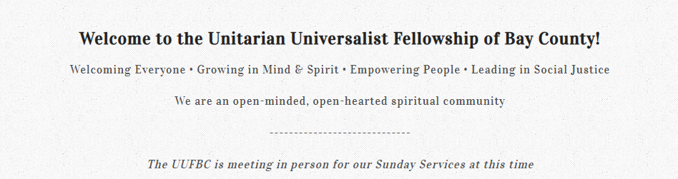
Sunday Fellowship Services; 10:30 in person and on YouTube. Address: 1410 Airport Rd, Panama City, FL
*Note! No longer on Zoom! YouTube link: https://www.youtube.com/@UUofBayCounty/streams

Announcement:
I will be turning over the newsletter to someone else, as of Labor Day. That day seems appropriate. I remember when Reverend Ruth called me and said, “I have something right up your alley!” It was a job I never knew I wanted. Putting together a newsletter was something I could do to contribute to the UUFBC, and I thank you for reading my communique every week. But now that I’m writing again, I need time to do it.
I don’t know who will be taking over for me, but rest assured, someone will step up. If you are interested, get in touch with Charissa Thacker. She may already have someone, but in case she doesn’t…
For Your Reflection
From 3 ideas in 3 minutes: Subscribe here for more…
A Fear of Failure can be paralysing. Bestselling author Robert Greene knows this aspect of the human condition all too well:
A lot of people are afraid of failure and so they never try anything in life. They never attempt that project, they never write that book, they never start that podcast. Because they’re afraid that if they do they’re going to fail. And failing is a worst feeling than actually kind of withdrawing from the world.
So you have to, like, force yourself, it’s not easy, to actually try and execute all those projects that are in your mind. But you have to do it with baby steps. You have to try something small first, you know, and overcome your fear of failure.
—Robert Greene

II. Upward Failure
Another reason to not fear failure is that it can still lead to success. Upward Failure describes the phenomenon of people succeeding despite being mediocre, incompetent or failing in general.
In a negative reading, it’s the colleagues who get promoted based on the Dilbert Principle (“ineffective workers are systematically moved to the place where they can do the least damage: management”). While you’ve been working hard, Bob from your team keeps getting promoted. Despite a poor record. And wearing shorts to the office.
In a positive reading, it’s the notion that messing up can lead to something better in the long run. You turn your setbacks and failures into rocket fuel. Maybe change jobs or careers, which puts you on a much more successful life path. It’s the notion that you cannot lose. Because even if you do, it always leads to something better.

III. Dignity of Risk-Taking
I think it’s fair to say that essayist Nassim Nicholas Taleb despises people who enjoy the upside of their decisions while offloading the potential losses onto others. That also means he respects the legends who take risks where they personally bear the consequences. There’s Dignity in Risk-Taking.
If you take risks and face your fate with dignity, there is nothing you can do that makes you small. If you don’t take risks, there is nothing you can do that makes you grand. Nothing. And when you take risks, insults by half-men, small men, those who don’t risk anything, are similar to barks by non-human animals. You can’t feel insulted by a dog.
―Nassim Nicholas Taleb, Antifragile
Upcoming Services
August 17: T-Shirt Sunday by Chris May
Don’t miss our popular “T-Shirt Sunday” when everyone is invited to wear a special shirt that has some personal meaning. It could be funny, political, a sports team, or a hand-me-down! During the service, you’ll be given an opportunity to briefly explain the significance of your chosen shirt. We have quite a few new members and friends this year. Talking about our shirts may help us get acquainted. We hope this service will leave you with a sense of belonging and a deeper understanding of each other.
Service Leader: Chris May

August 24: “The Quiet Revolution: Radical Self-Care and Restoration.” Speaker: Michael Lister
Service Leader: Bob Gilmore
Join as we welcome Michael Lister back to the UUFBC.

August 31: Reading your values: Building Empathy through stories by Katherine McGinnis

UUFBC Book Club

The new book selection is a banned book. "They Called Us Enemy," written by George Takei is his memoir of growing up in Japanese internment camps during World War II. It highlights the importance of taking a stand against injustice. The discussion will probably take place in September.

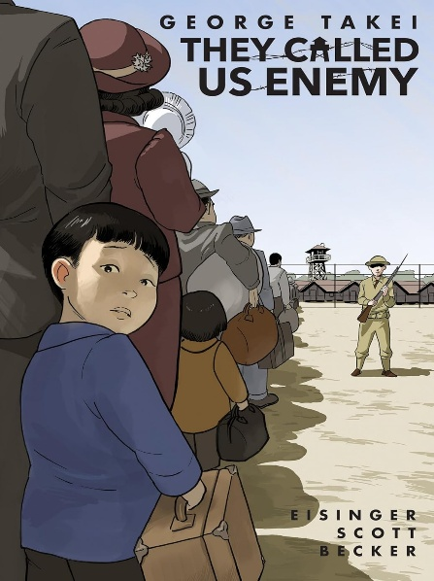

Activist News



MEET AND GREET WITH NIC ZATESLO, CANDIDATE FOR CONGRESS

Two Dems are vying for the chance to run against Neal Dunn. DWC has arranged for you to meet and hear from both of them. The first event is Wed, August 27 with Nic Zateslo. RSVP below.



Click to RSVP.

RSVP

For other ways to voice your most pressing concerns, check out 5 calls!
https://5calls.org/
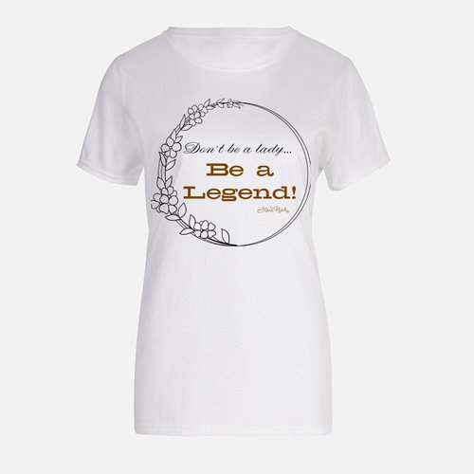

UUFBC Website https://www.uuofbaycounty.com/
UUFBC Facebook Page https://www.facebook.com/uubaycounty

There’s also a Facebook page for the LGBTQ center. That and a lot of other info is on their website: https://gulfcoastlgbtqcenter.org

Newsletter Editor: Cindy Gregory – Please email me anything you want included by Thursday!
President: Charissa Thacker
Vice President: Joan McDonald
Treasurer: Jennifer Grant
Secretary: Katherine McGinnis
Member at large: Bob Gilmore
Member at large: Bob McNeal
Member at large: Shelly Lamie

Contact info: 850- 615-4127 *Office Hours are Tuesday 10 a.m. – noon (leave a message, please)
To submit information for the biweekly e-newsletter, send to info@uuofbaycounty.com and please cc cindykg@gmail.com

